Game Design Document

Fill up the Following document

1. Write the title of your project.

Trouble of quiz master

1. What is the goal of the game?

To collect keys and solve quiz

1. Write a brief story of your game?

***This is a story of a missions of main hero ray.***

***He has an order from prime minister to***

***Save people caught by quiz master.***

***According to pm the people caught by quiz master.***

***Are very smart highly qualified in weapon making.***

***They can make weapons which can destroy a whole country.***

***Quiz mister is planning to destroy our country with the help of***

***That smart people.***

1. Which are the playing characters of this game?

* Playing characters are the ones which respond to the user based on the input from the user
* Cars, monkeys, dinos, wizards etc, are the playing characters in the game.

|  |  |  |
| --- | --- | --- |
| Number | Character Name | What can this character do? |
| 1 | ray is a name of main  character | can jump  solve quiz |
| 2 | jet plane | fire on obstacles |
| 3 | submarine | travel |

1. Which are the Non Playing Characters of this game?

* Non Playing characters are the ones which don't have an action or a behavior when the user interacts with the game.
* Hurdles, stones, bananas, coins, etc are non playing characters in the game.

|  |  |  |
| --- | --- | --- |
| Number | Character Name | What can this character do? |
| 1 | stones | obstacle for  playing character |
| 2 | lion | attack on playing  character |
| 3 | tiger | attack on playing  character |
| 4 | fishes | attack on playing  character |
| 5 | shark | attack on playing  character |
| 6 | fire ball | attack on playing  character |
| 7 | dragon | attack on playing  character |
| 8 | monsters | attack on playing  character |

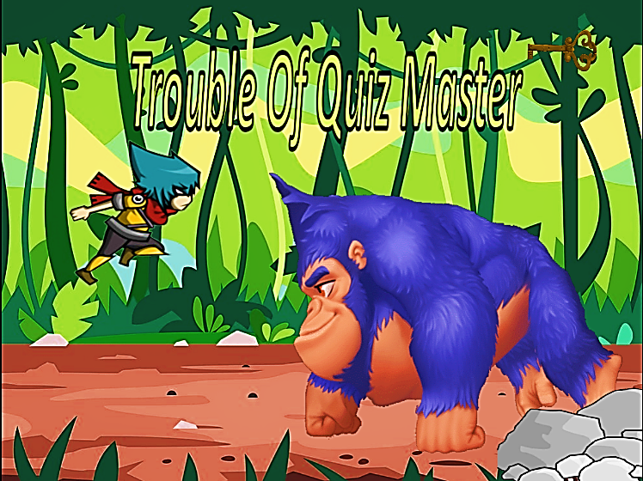

Draw your imagination of this game. What does this game look like?

* Draw the game either on your computer or on paper,
* Add images of scenes of the game to show each of the playing and non-playing characters at least once.

How do you plan to make your game engaging?

By making game adoptive according to level.

Using sound effect.